**NAME : K VENKATA ABHIRAM**

**REG NO : 192124154**

**ITA1471-ETHICAL HACKING**

**LAB MANUAL**

**Exercise No 1:** **Nmap Scan**

**Aim:**

To install and perform Nmap scan (note :- you may use ip address or website name)

**Procedure:**

Step 1: Open Nmap from Kali Linux (Goto Applications->select Information Gathering->select

Nmap)

Step 2: Perform different types of scan

(Tcp, Udp, Ack, Syn, Fin, Null, Xmas, Rpc, Idle)- scan types

**Scanning Techniques**

|  |  |  |
| --- | --- | --- |
| **Flag** | **Use** | **Example** |
| **-sS** | **TCP syn port scan** | **nmap -sS 192.168.1.1** |
| **-sT** | **TCP connect port scan** | **nmap -sT 192.168.1.1** |
| **–sU** | **UDP port scan** | **nmap –sU 192.168.1.1** |
| **–sA** | **TCP ack port scan** | **nmap –sA 192.168.1.1** |
|  |  |  |

Step 3:-

To perform host discovery

|  |  |  |
| --- | --- | --- |
| -Pn | only port scan | nmap -Pn192.168.1.1 |
| -sn | only host discover | nmap -sn192.168.1.1 |
| -PR | arp discovery on a local network | nmap -PR192.168.1.1 |
| -n | disable DNS resolution | nmap -n 192.168.1.1 |

Step4:-

**Port Specification**

|  |  |  |
| --- | --- | --- |
| **Flag** | **Use** | **Example** |
| **-p** | **specify a port or port range** | **nmap -p 1-30 192.168.1.1** |
| **-p-** | **scan all ports** | **nmap -p- 192.168.1.1** |
| **F** | **fast port scan** | **nmap -F 192.168.1.1** |

Step 5:-

***Service Version and OS Detection***

|  |  |  |
| --- | --- | --- |
| Flag | Use | Example |
| -sV | detect the version of services running | nmap -sV 192.168.1.1 |
| -A | aggressive scan | nmap -A 192.168.1.1 |
| -O | detect operating system of the target | nmap -O 192.168.1.1 |

Step 6:-

Timing and Performance

|  |  |  |
| --- | --- | --- |
| Flag | Use | Example |
| -T0 | paranoid IDS evasion | nmap -T0 192.168.1.1 |
| -T1 | sneaky IDS evasion | nmap -T1 192.168.1.1 |
| -T2 | polite IDS evasion | nmap -T2 192.168.1.1 |
| -T3 | normal IDS evasion | nmap -T3 192.168.1.1 |
| -T4 | aggressive speed scan | nmap -T4 192.168.1.1 |
| -T5 | insane speed scan | nmap -T5 192.168.1.1 |

**Output:**

**Step 1:** Open Nmap from Kali Linux (Goto Applications->select Information Gathering->select

Nmap)

**Step 2:** Perform different types of scan

(Tcp, Udp, Ack, Syn, Fin, Null, Xmas, Rpc, Idle)- scan types

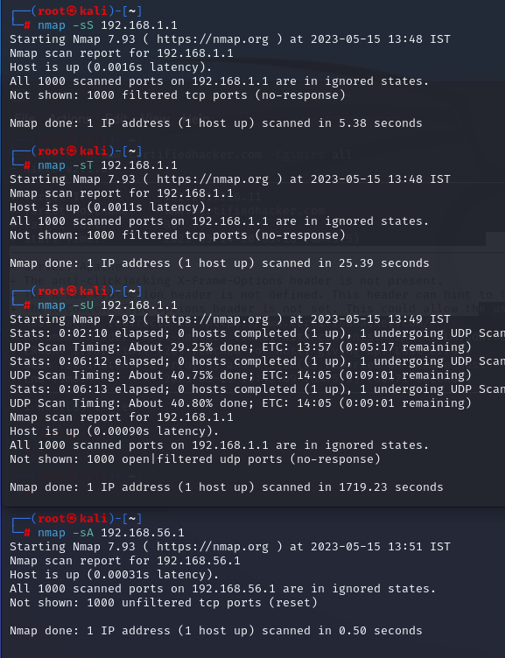

**Step 3:-**

To perform host discovery

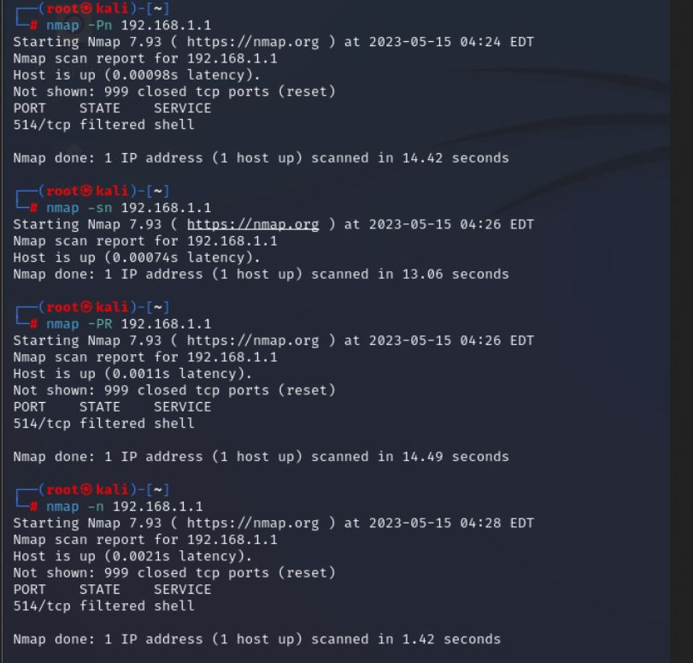

**Step4:-**

**Port Specification**

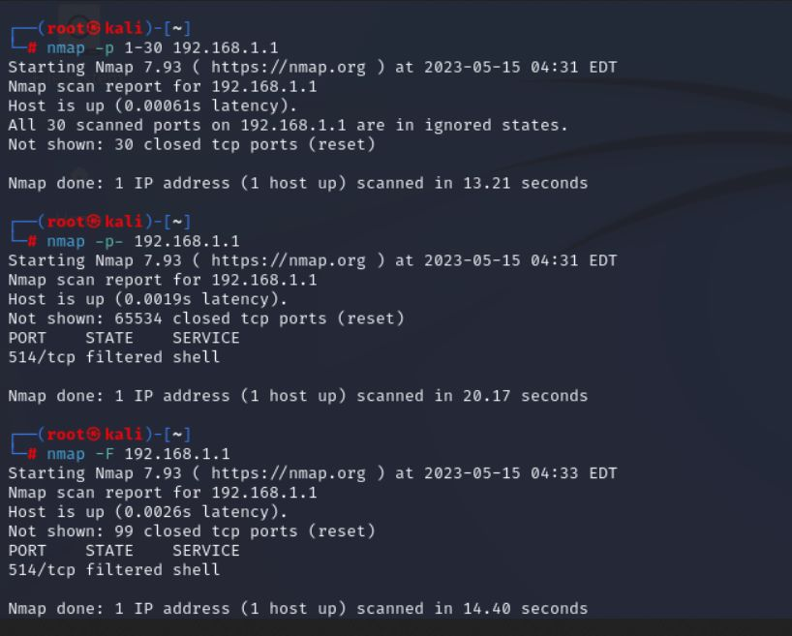

**Step 5:-**

***Service Version and OS Detection***

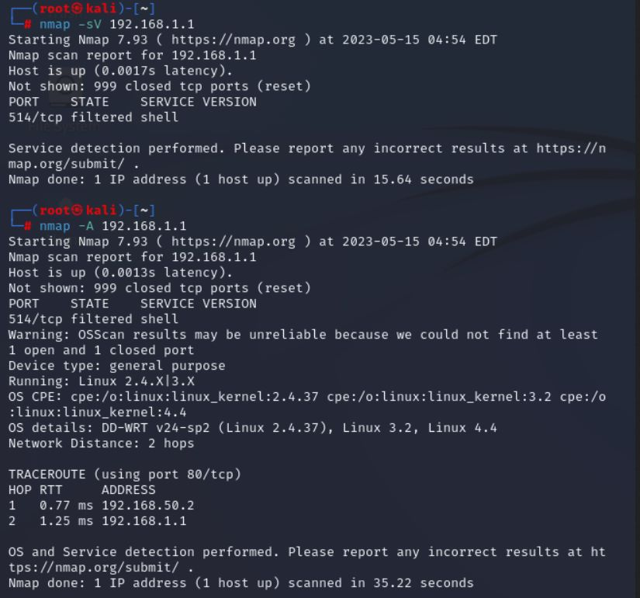

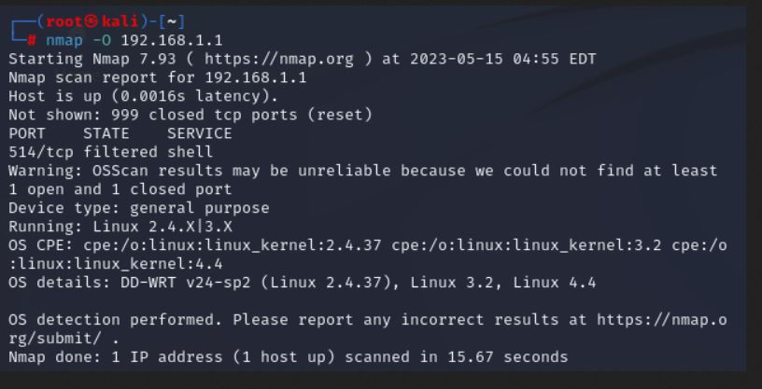

Result:Nmap has been executed successfully.

**Exercise No 2:** **Vulnerability Access Scan Using Nessus**

**Aim :** To Download and install Nessus tool and perform a Vulnerability Access scan in kali Linux Operating systems.

Step 1:- <https://www.tenable.com/downloads/nessus?loginAttempted=true>

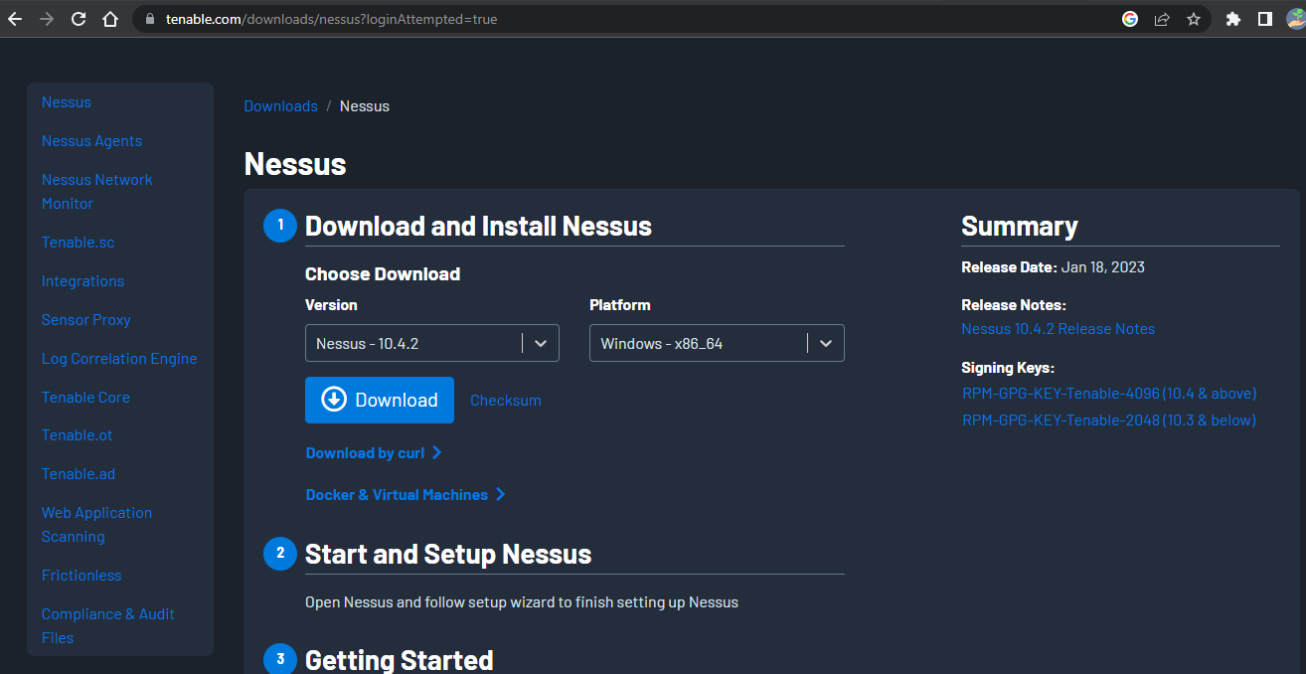

Step 2: Choose your OS and download , install

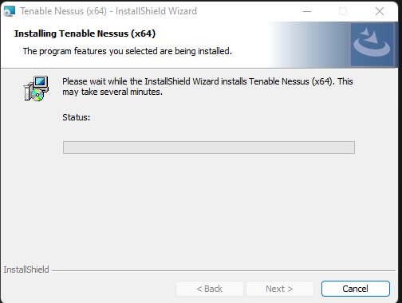

Step 3: Once installation is completed it will open in default browser

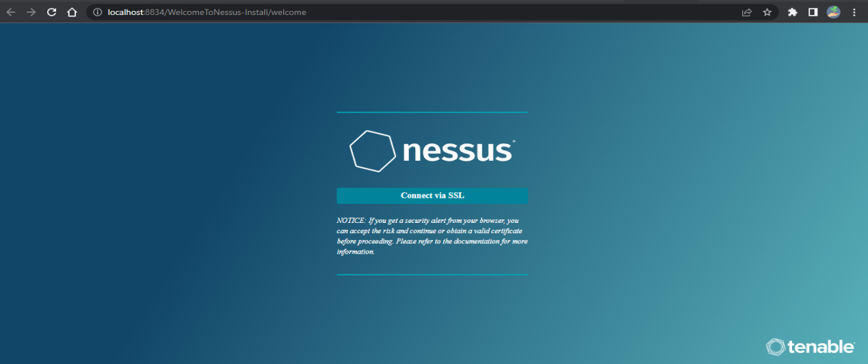

Step 5:- (click on the proceed to local host)

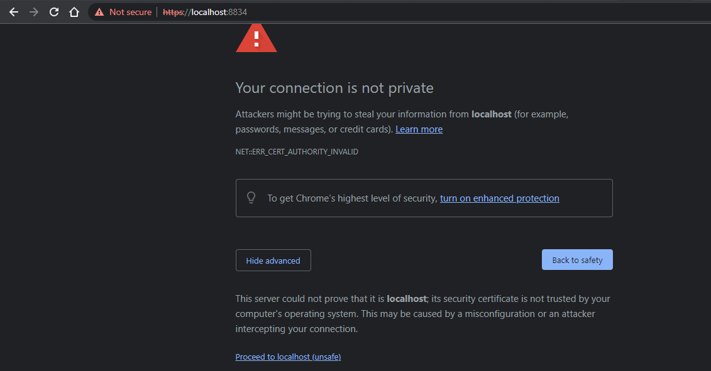

Step 6:- Please choose the Nessus Expert

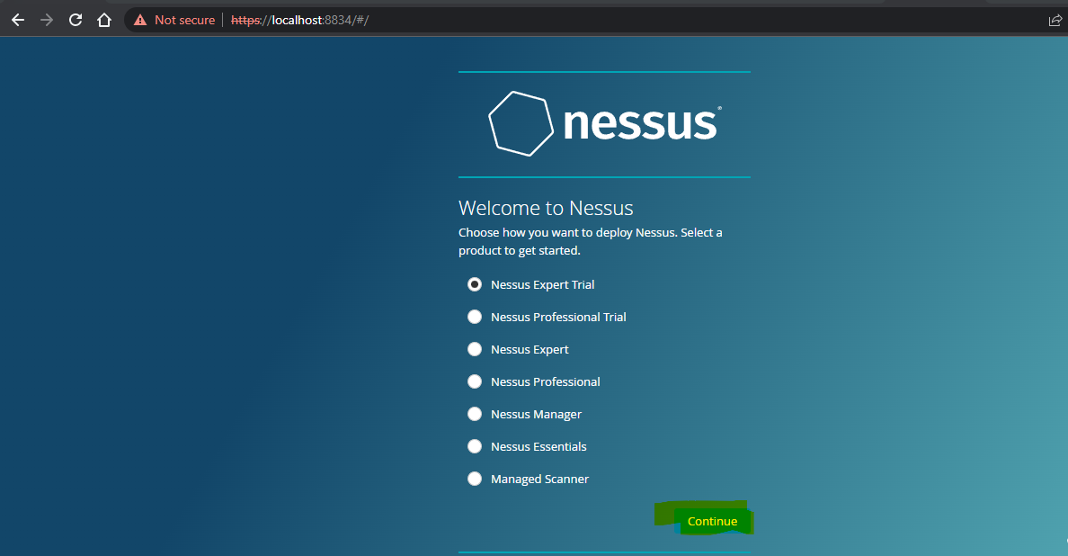

Step 7: Click on continue

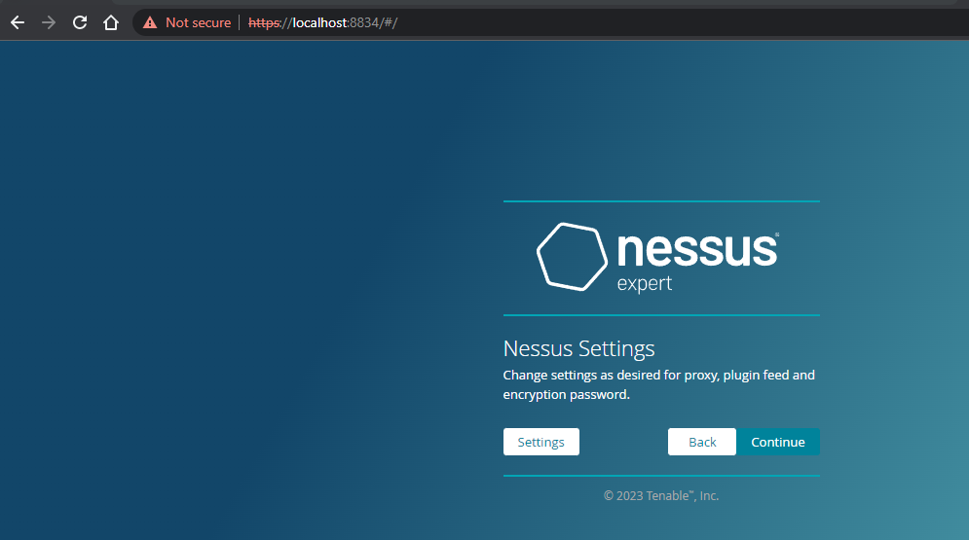

Step 8:- Register with your organizational email id

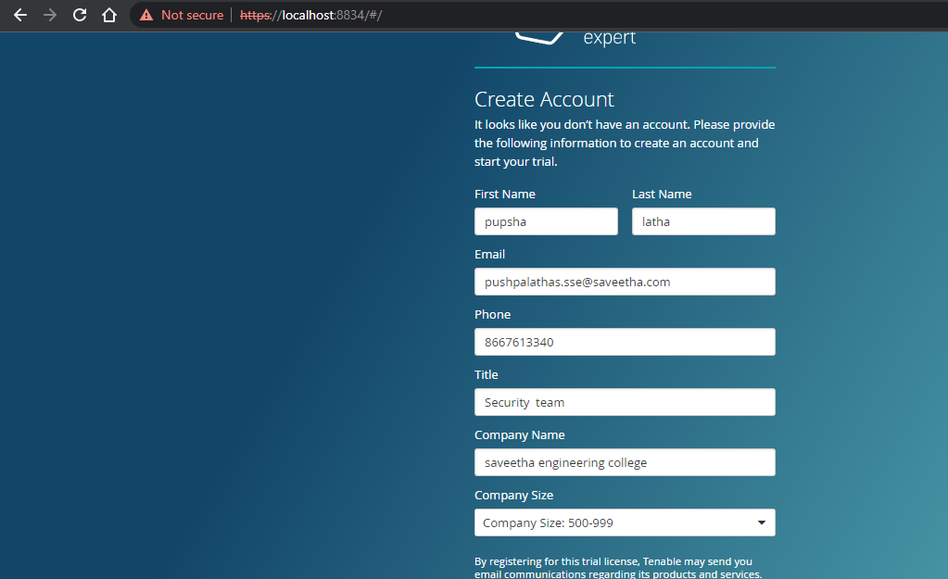

Step 9:- please note down the activation key

## **Trial License Information**

Activation Code: R4A2-DPDT-UVQZ-T53Y

Valid until: 2023-01-28

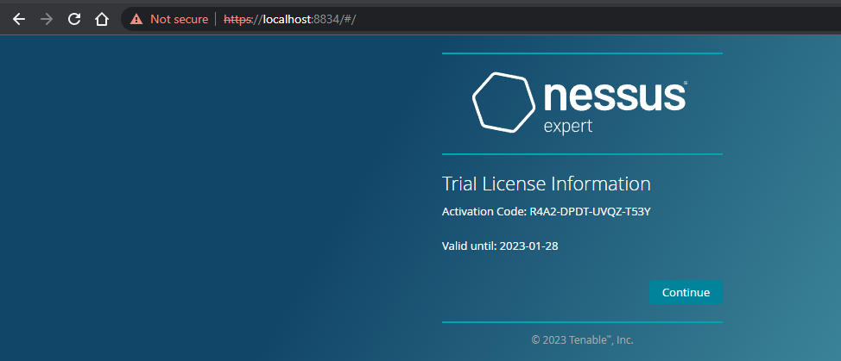

Step 10:- set up your username & password

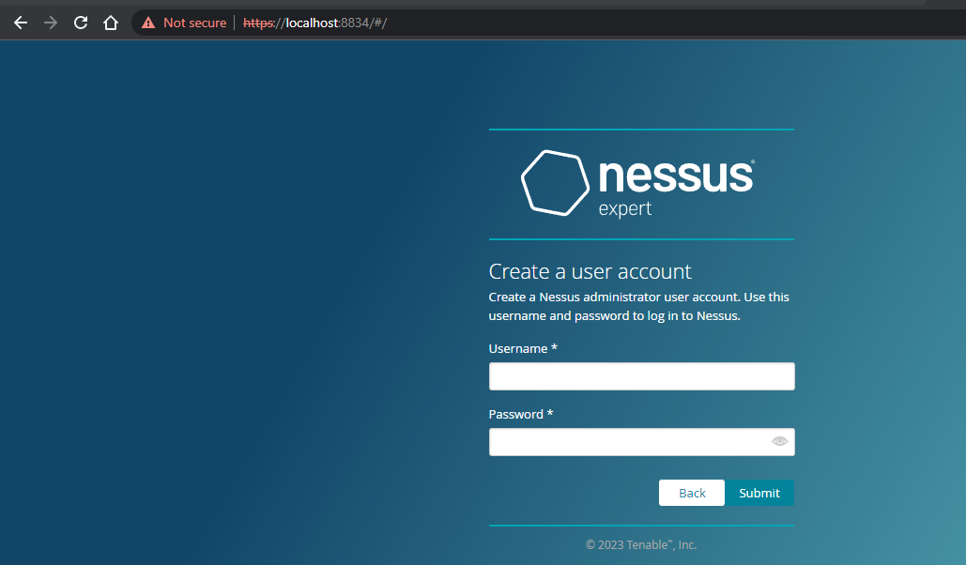

Step 11:-Type username and password

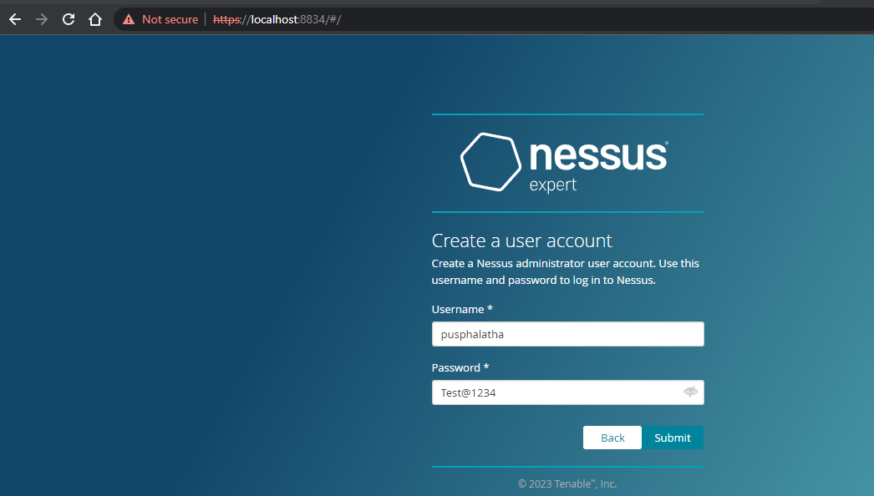

Step 12:- Please wait until download is completed

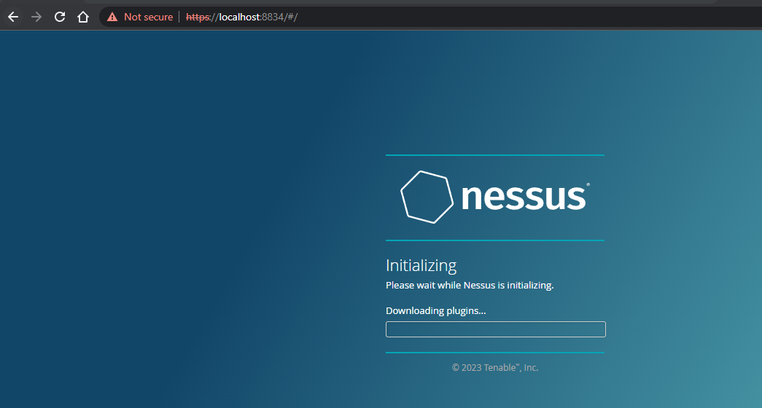

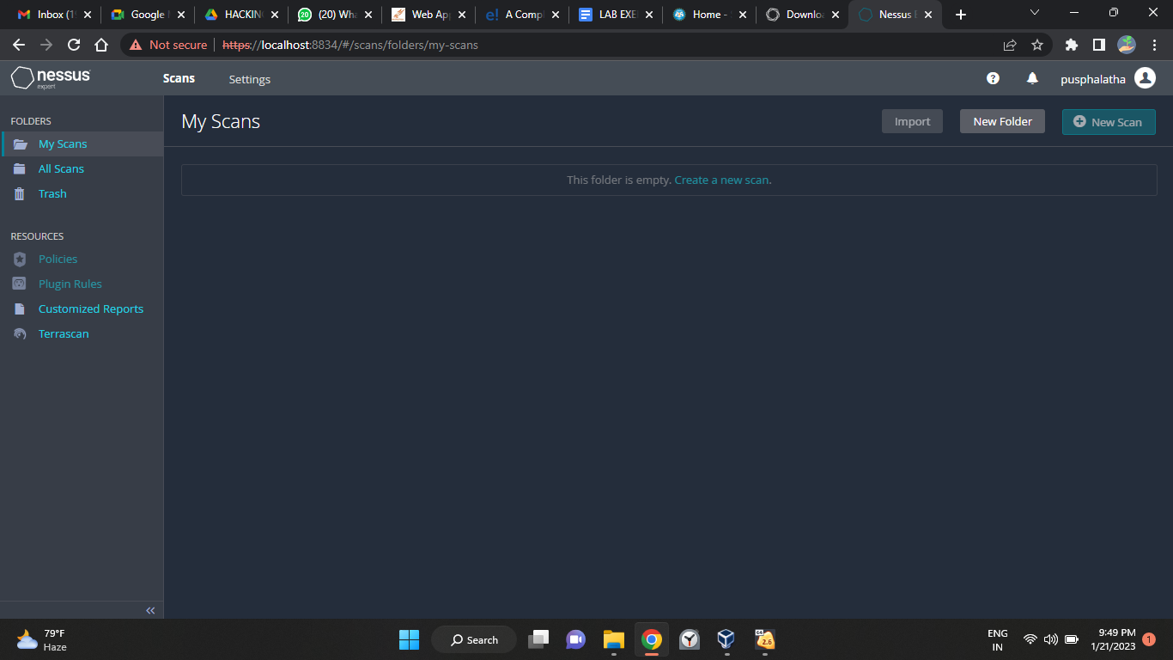

**Out Put:**

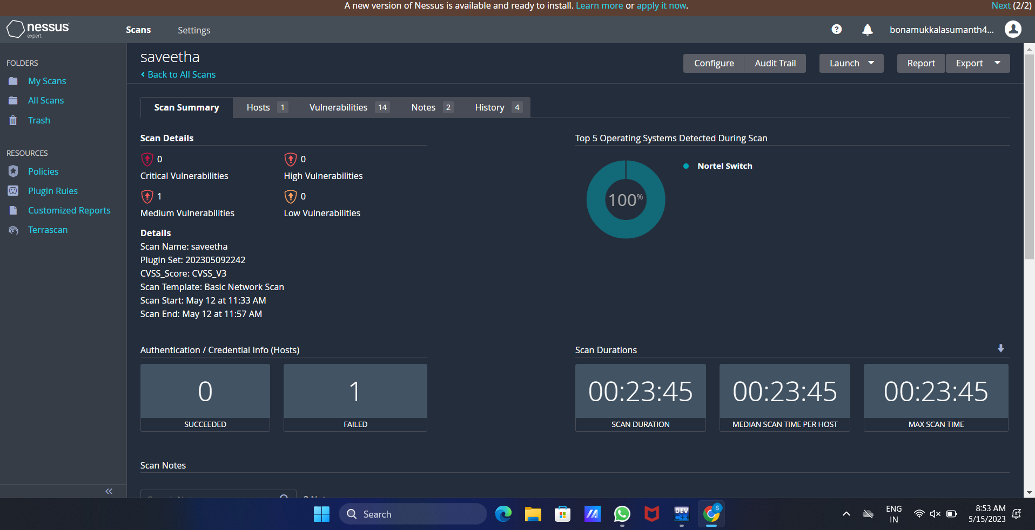

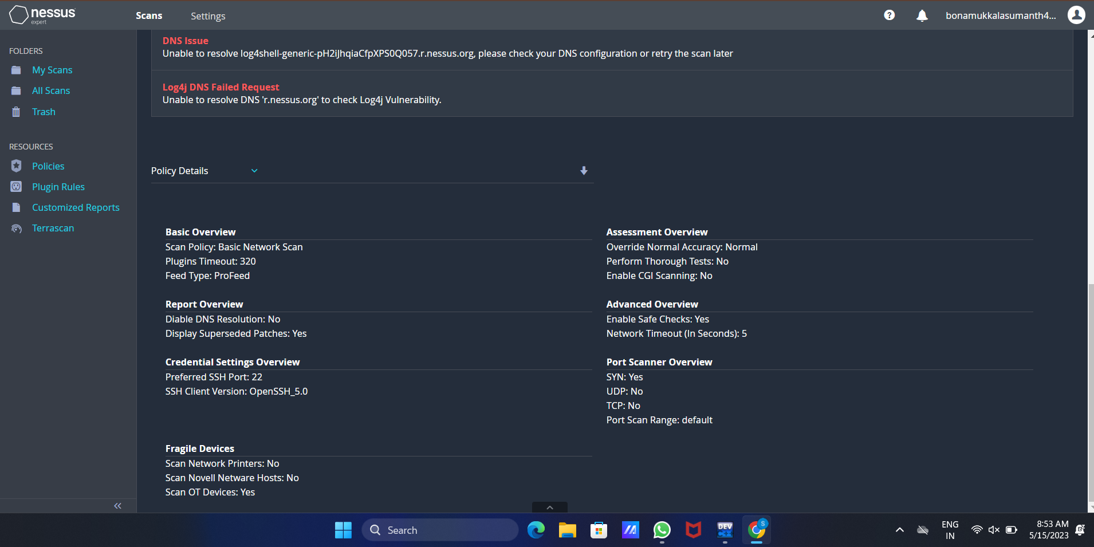

Exercise No 3: Information gathering using theHarvester

Aim: To demonstrate information gathering using theHarvester

Procedure:

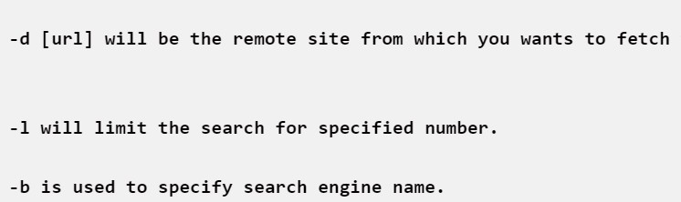**STEP 1: Open Terminal in the kali linux**

**STEP 2: Run the following command**

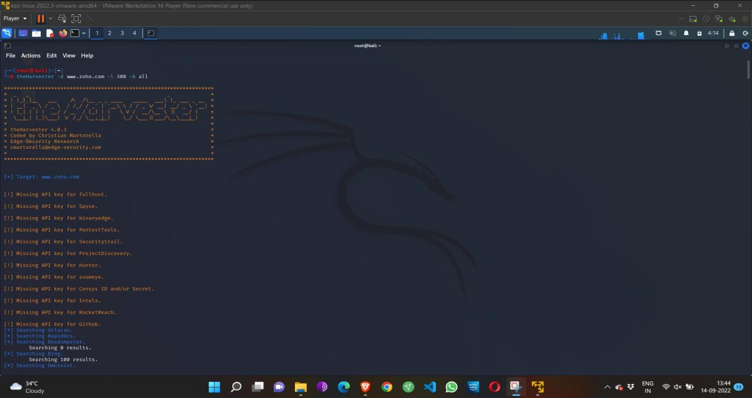**Command: theHarvester -d [www.zoho.com](http://www.zoho.com/) -l 3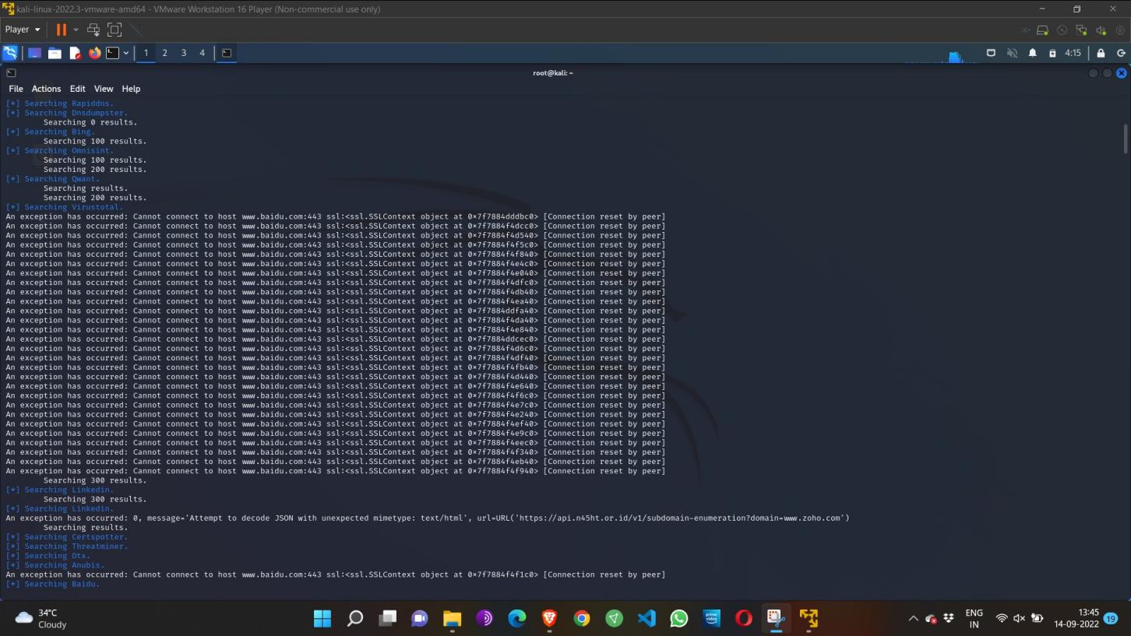00 -b all**

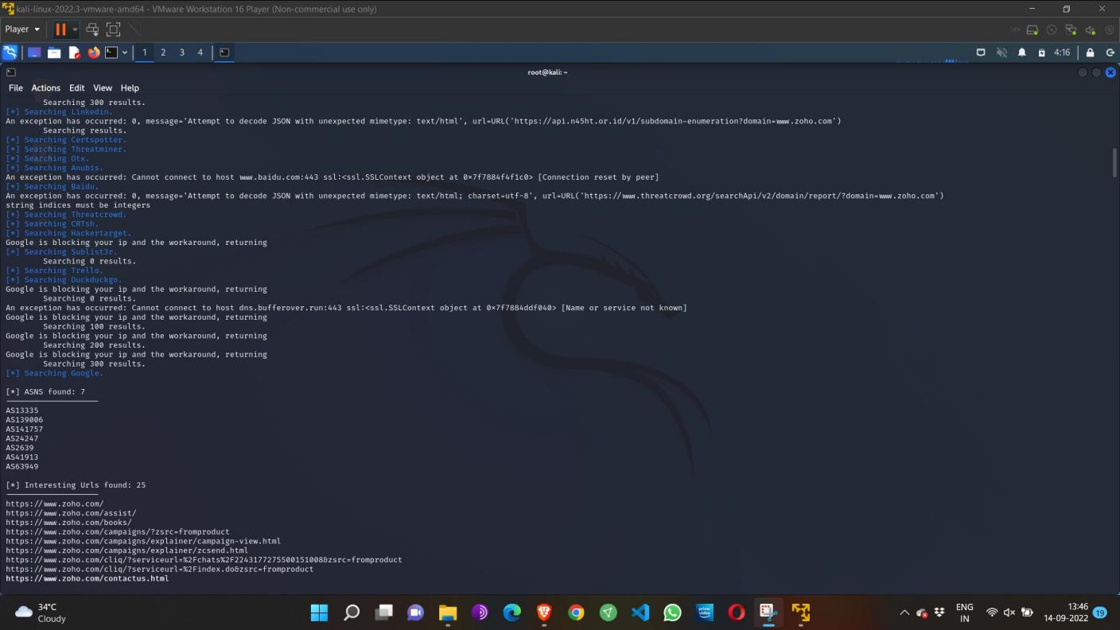

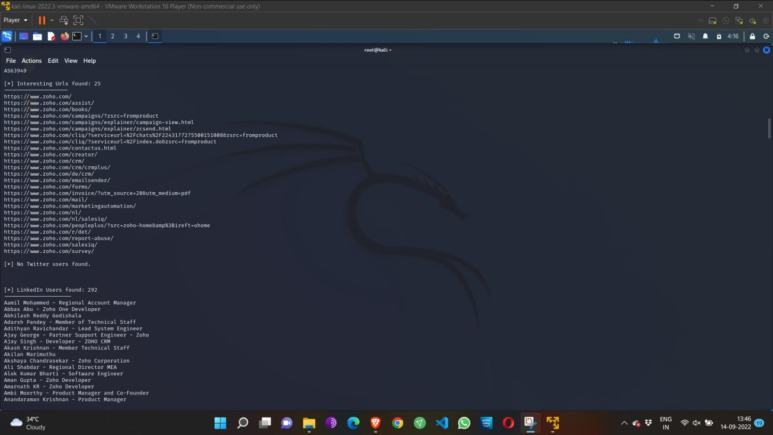

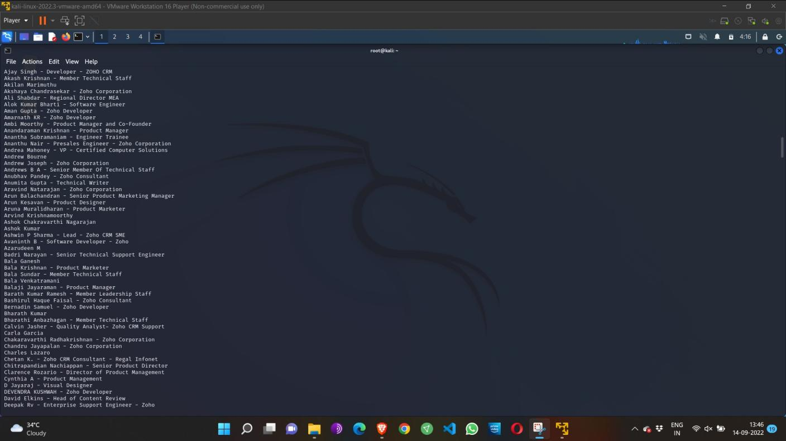

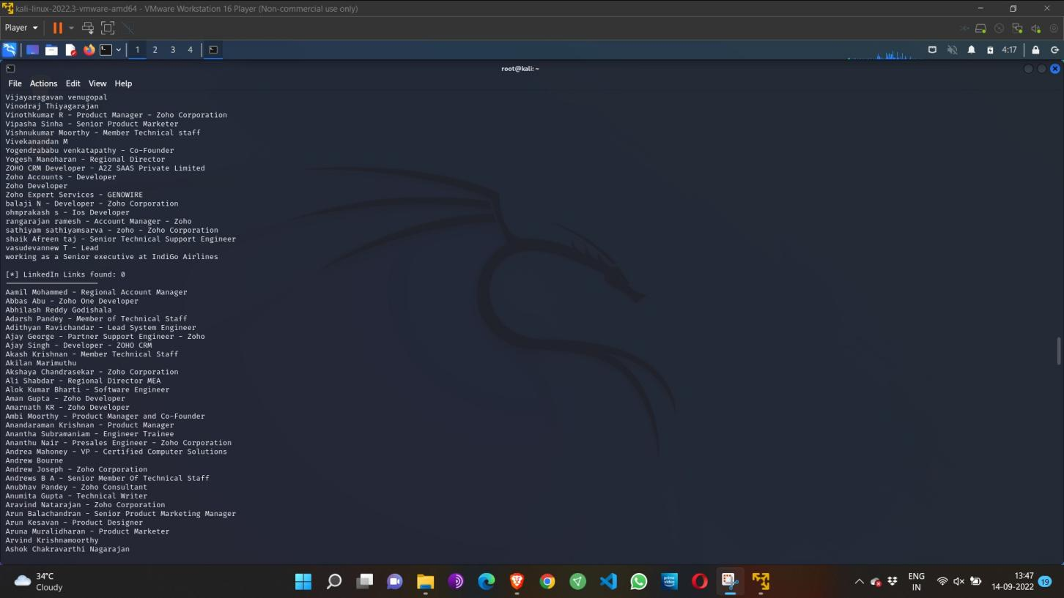

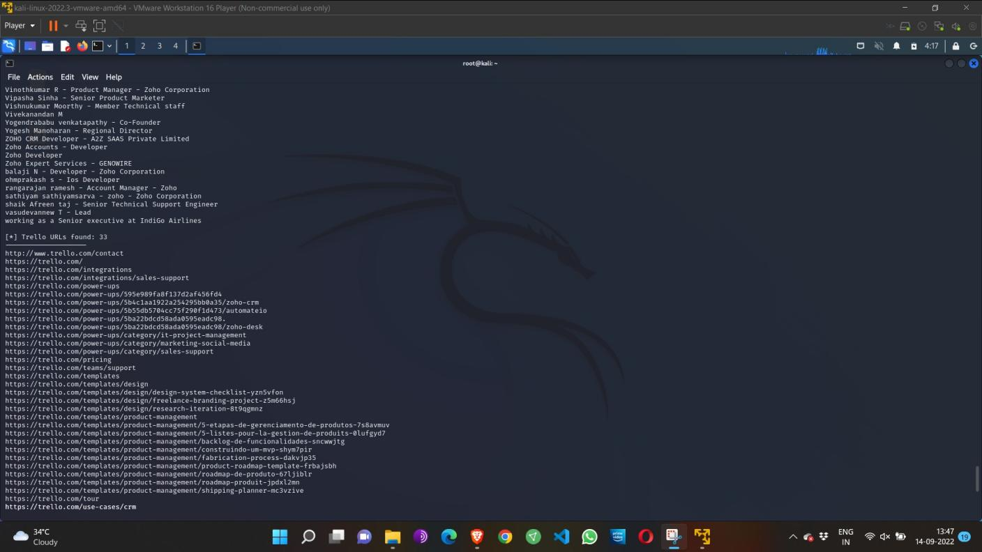

Step 4: run this command “**theHarvester -d [www.zoho.com](http://www.zoho.com/) -l 300 -b all -f test” and** hit enter to export the result as html file and xml file

Step 5: now close the terminal and navigate the home folder and search for test file .

**Out Put:**

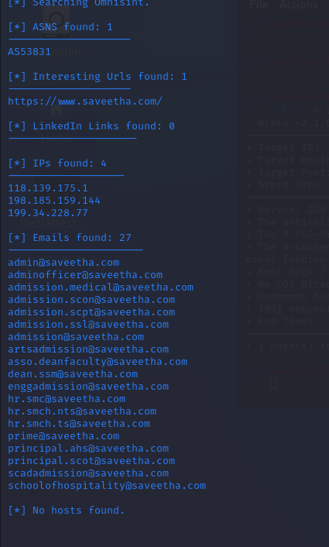

**Exercise No 4- Open Source Intelligence Gathering Using OSRFramework**

**Aim:** To Checks for the Existence of a Profile for given user details in different platforms

**Procedure:**

Step 1: Log into kali linux machine

Step 2: Launch a command line terminal by clicking on terminal icon from taskbar

Step 3: Usufy.py checks for the existence of a profile for given user details in different

platforms

**Command:**

## Usufy.py -n <Target username or profile name> -p twitter facebook youtube

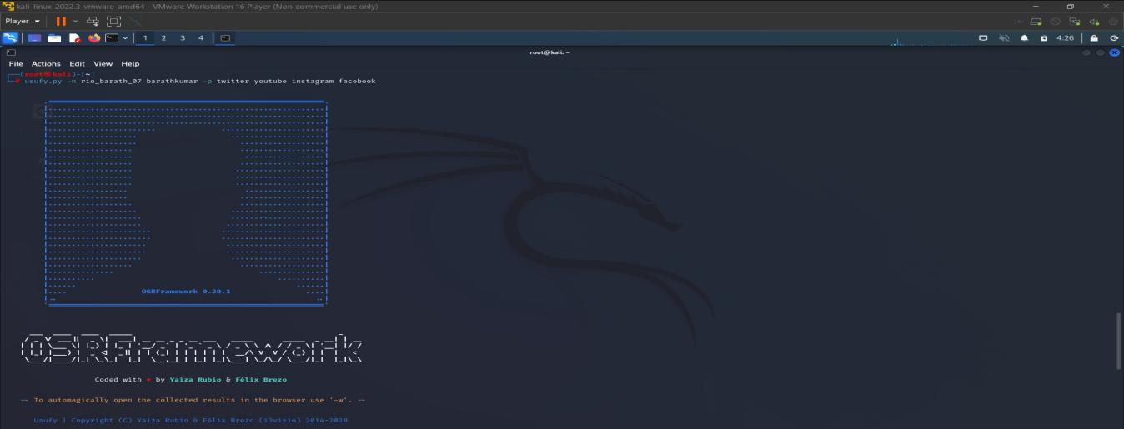

If any error occurs Try this command: **Sudo apt-getupdate**

## The usufy.py will search the user details in the mentioned platform and will provide you with the existence of the user

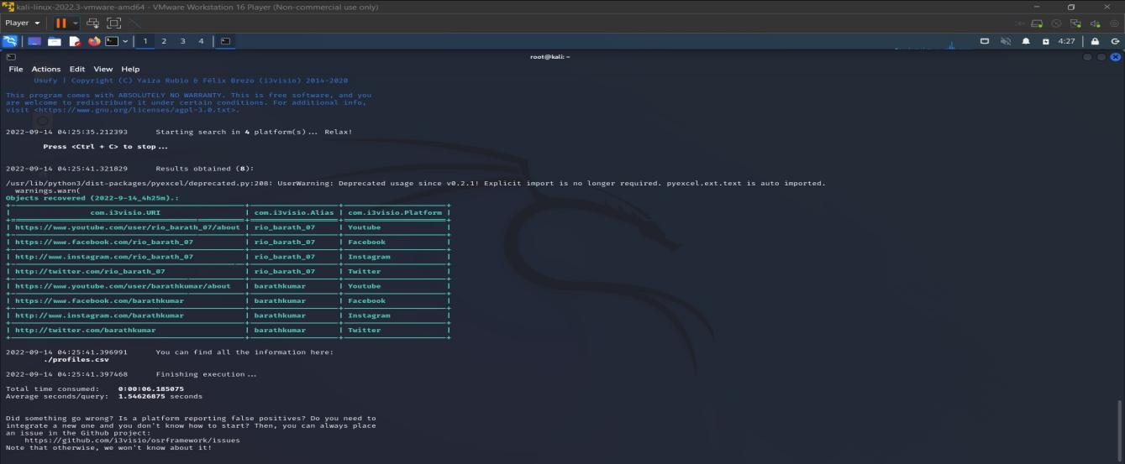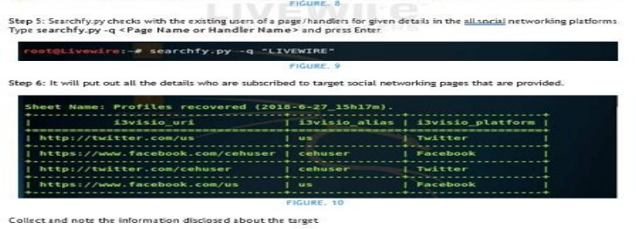

**Out Put:**

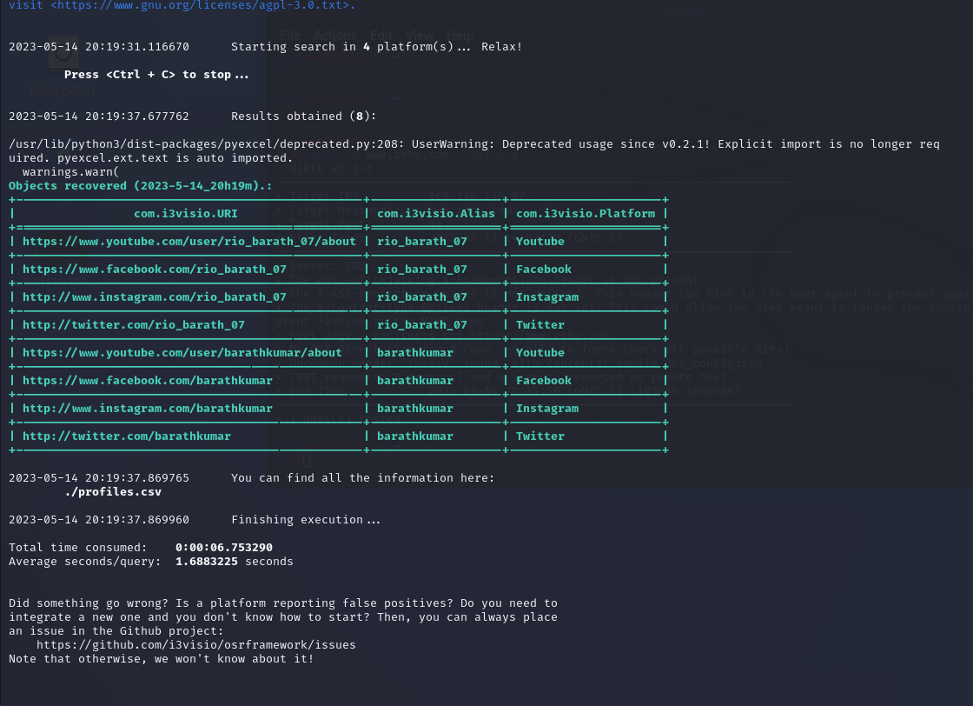

**Exercise NO 5: Use Google and Whois for Reconnaisasance.**

Aim: To find out the Whois, DNS Records and Diagonstics for particular website by using Whois search.

Procedure:

Step1: Open the WHO.is website

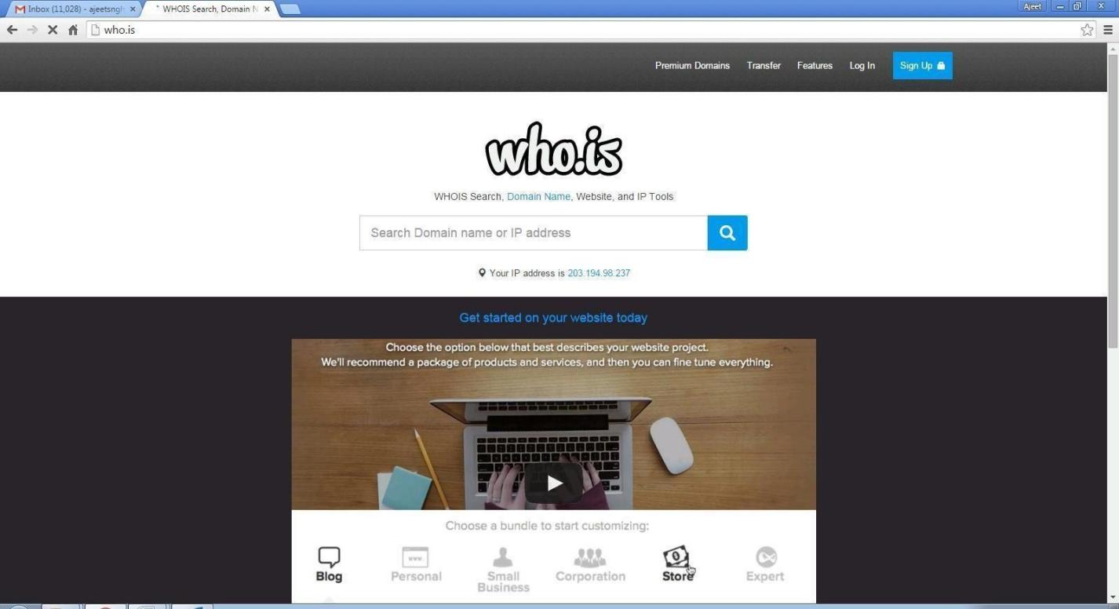

Step 2: Enter the website name in search bar and hit the “Enter button”. Step 3: Show you information about [www.saveetha.com](http://www.saveetha.com/)

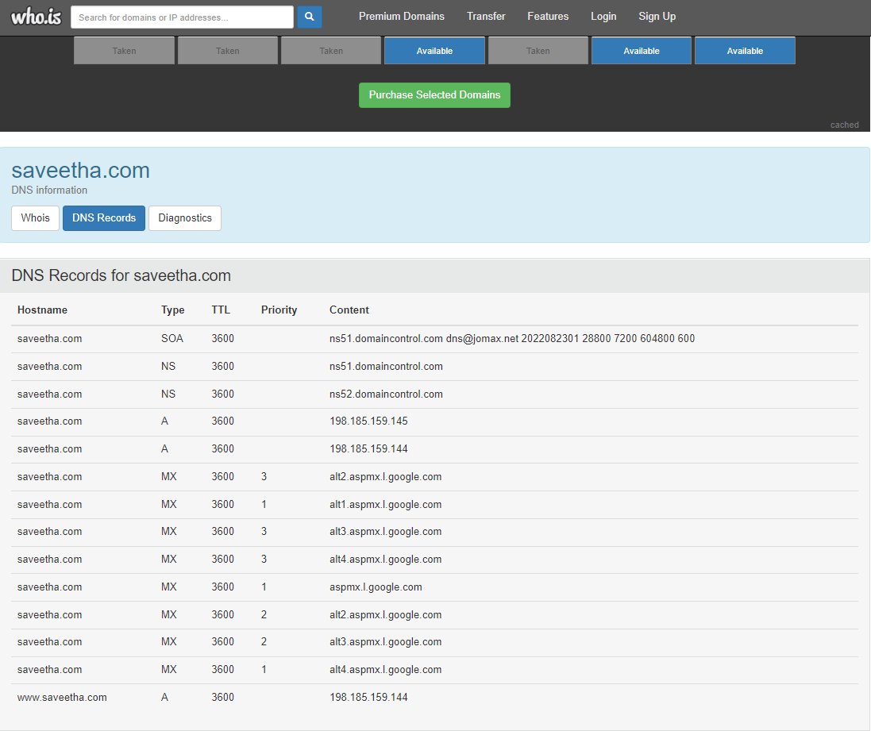

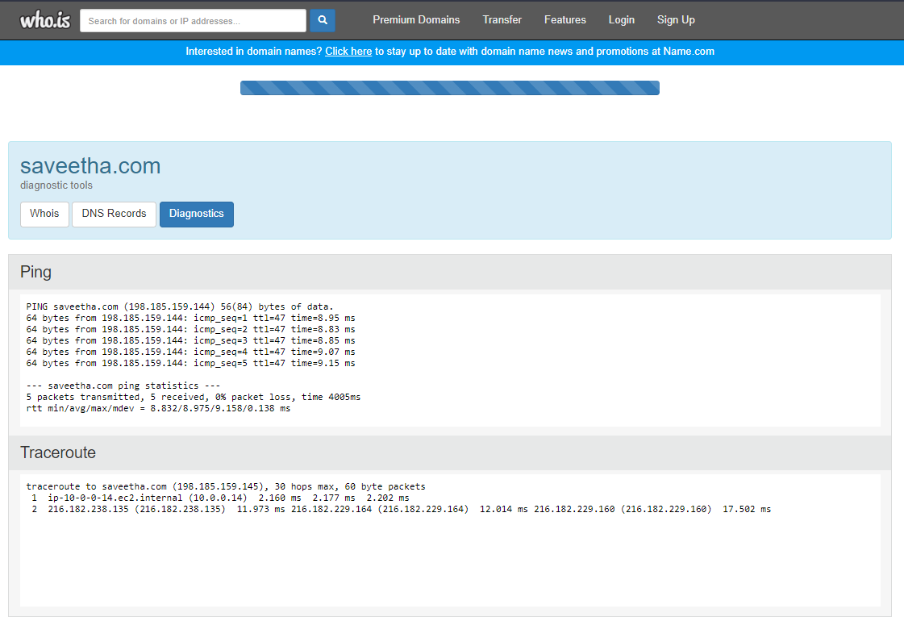

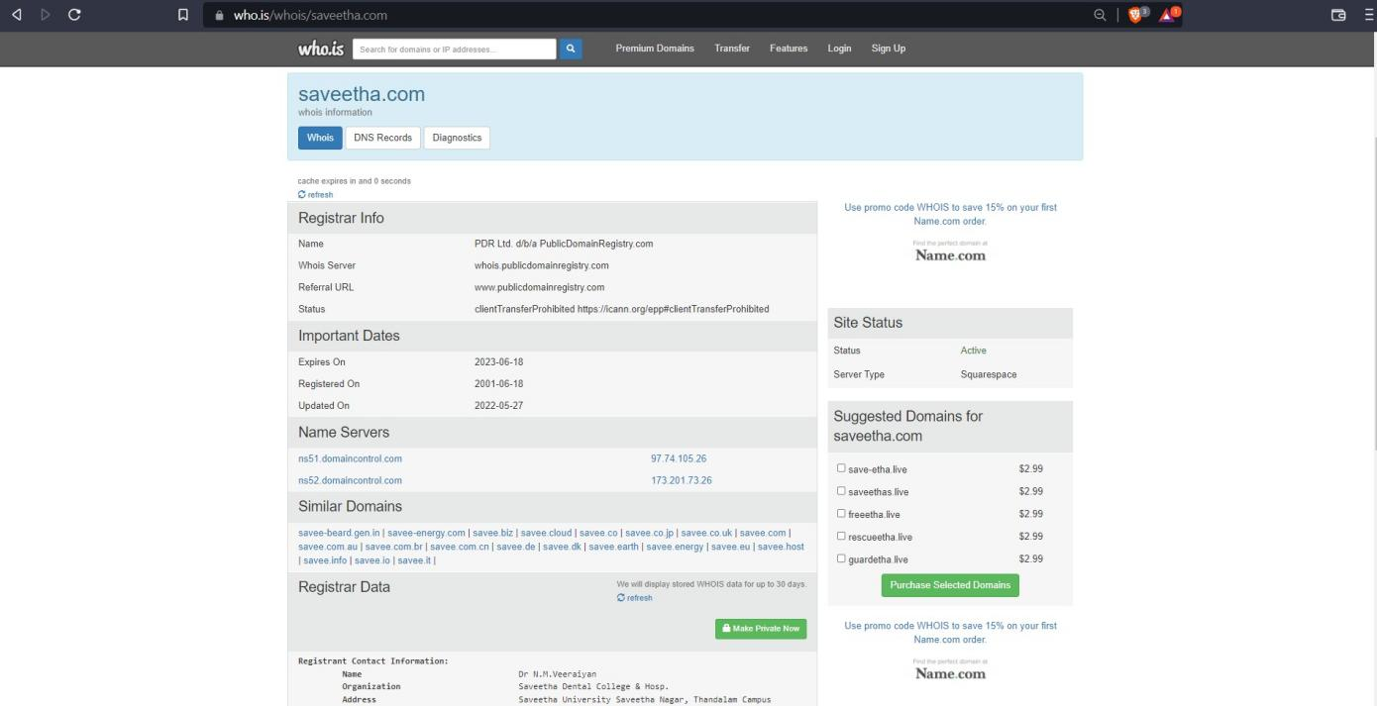

**Out Put:**

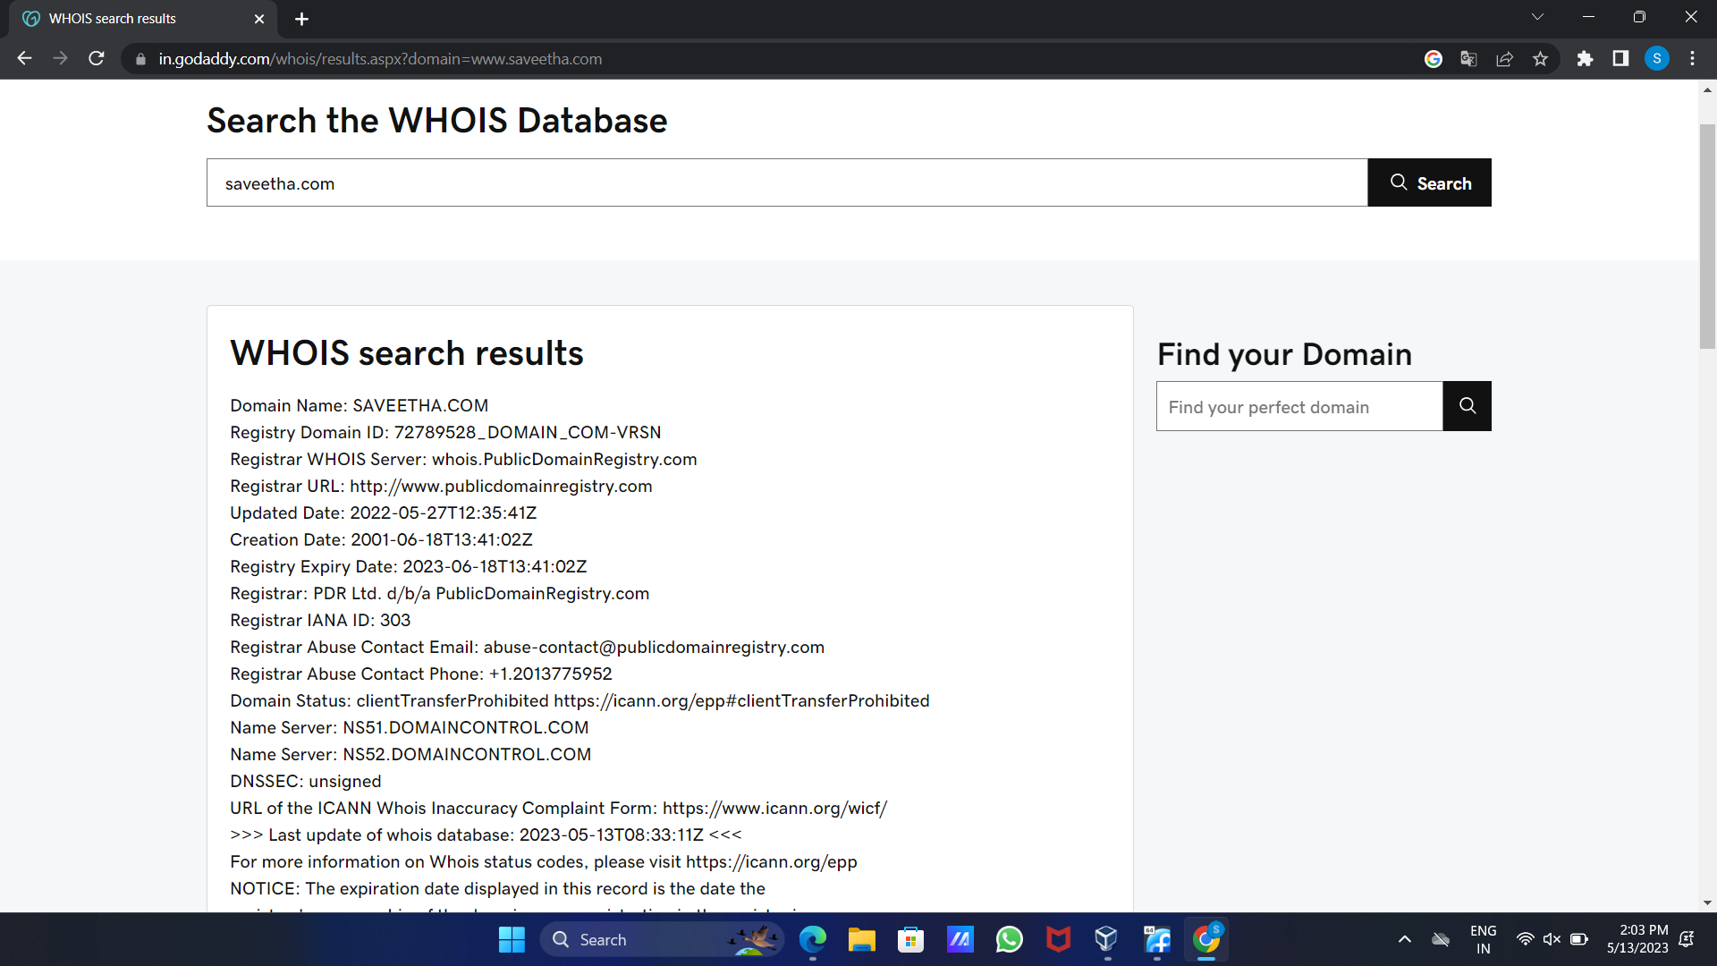

**Exercise No 6: TraceRoute, ping, ifconfig, ipconfig, netstat**

**Aim: Using TraceRoute, ping, ifconfig(LINUX), ipconfig(WINDOWS), and netstat**

**Command.**

Procedure:

Step 1: open windows command prompt and Type tracert command and type tracert

[www.saveetha.com](http://www.saveetha.com/) -> “Enter”

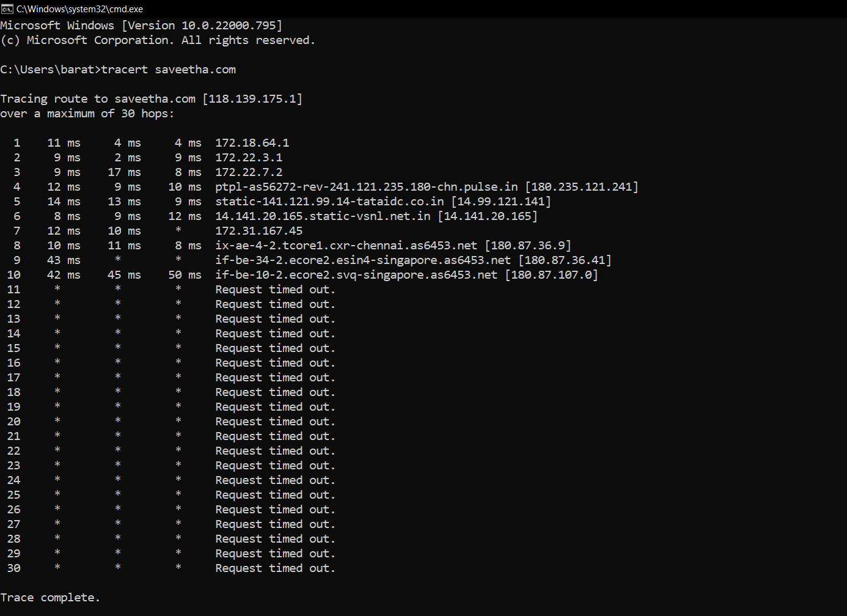

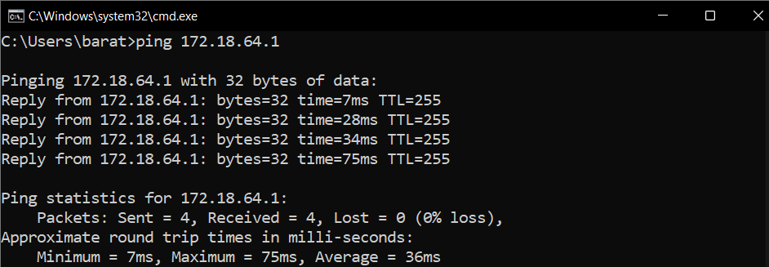Step 2: Type ping command and type IP Address press “Enter”

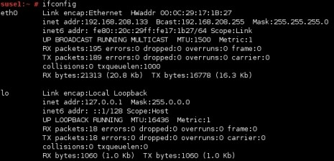Step 3: Type ifconfig command

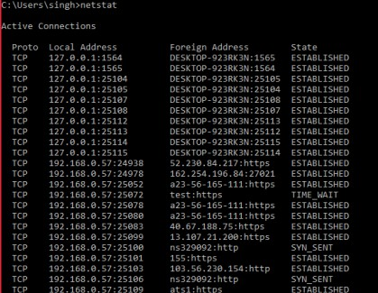Step 4: Type netstat c

**Out Put:**

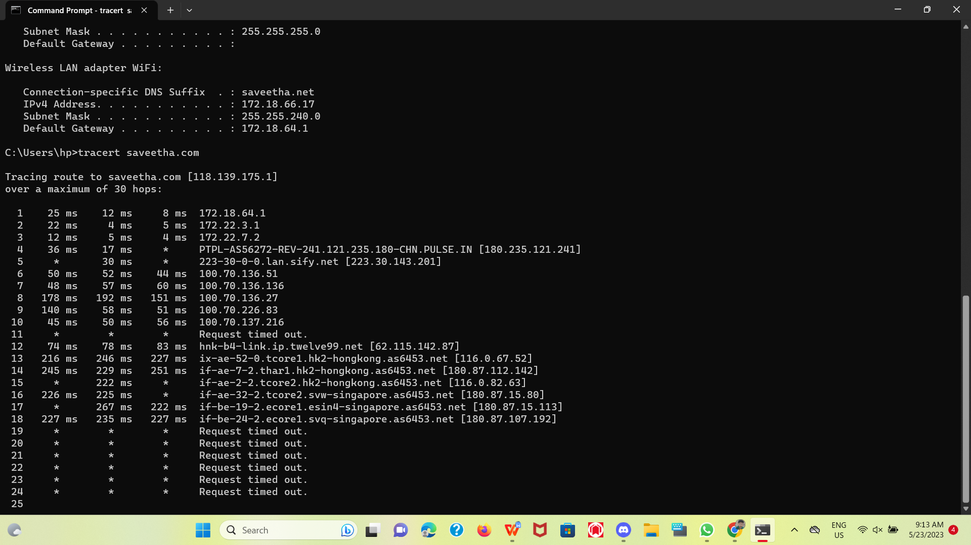

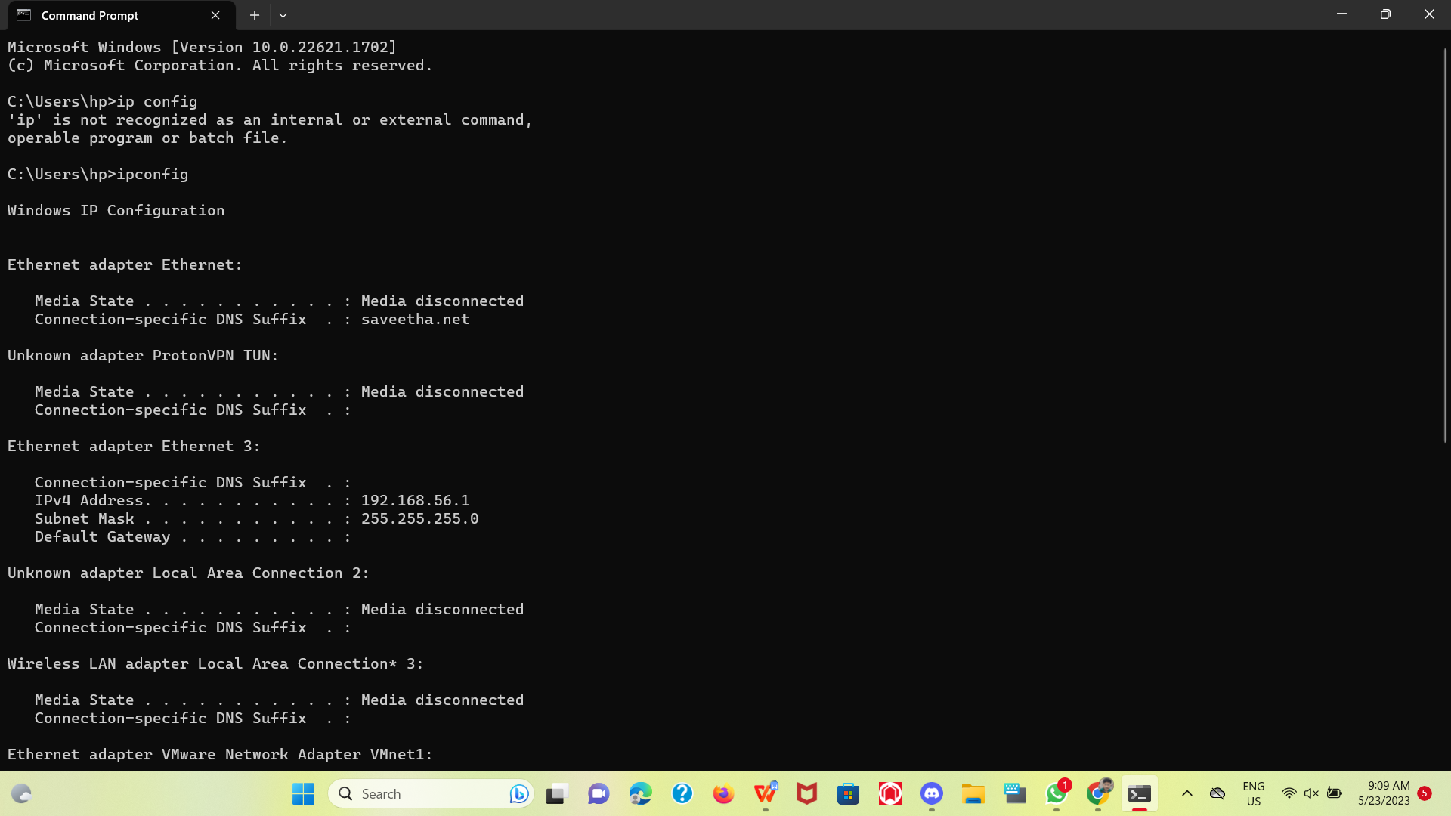

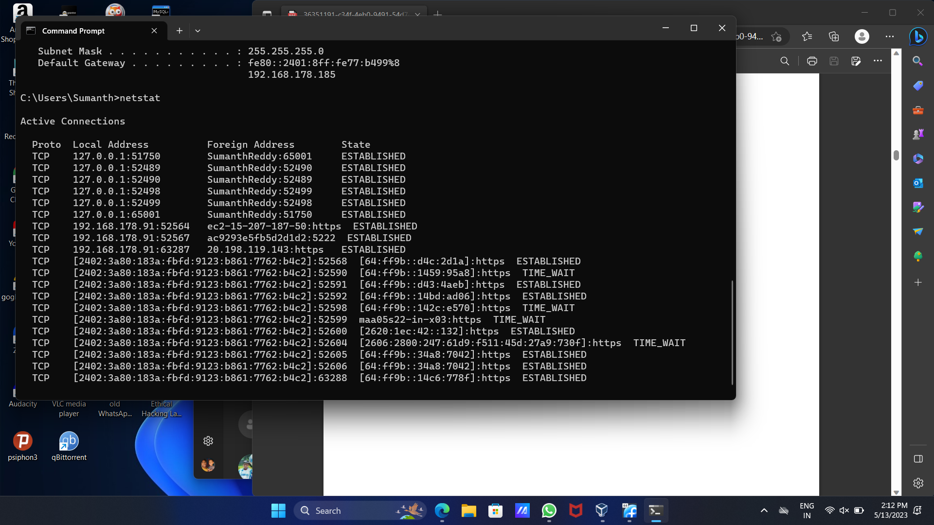

Exercise No 7:VULNERABILITY ANALYSIS - CGI Scanning with Nikto

Aim:To perform vulnerability Analysis using CGI Scanning with Nikto

Procedure:

Step 1: open a terminal window and type nikto –H and press enter

Step 2: Type nikto –h <website> Tuning x and press enter

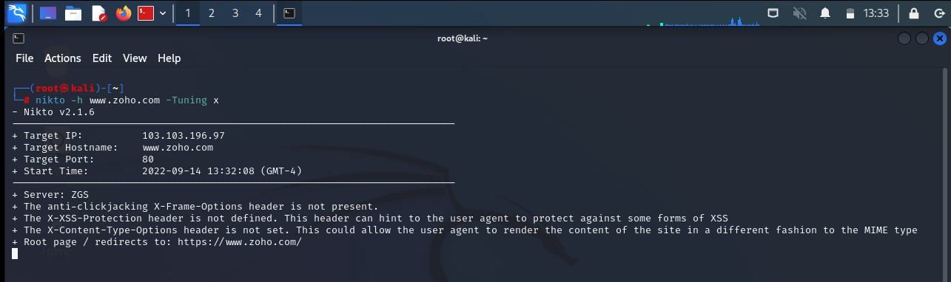

Step 3: Nikto starts web server scanning with all tuning options enabled.

Step4:In the terminal window type “nikto –h <website>-Cgidirs all”and hit enter

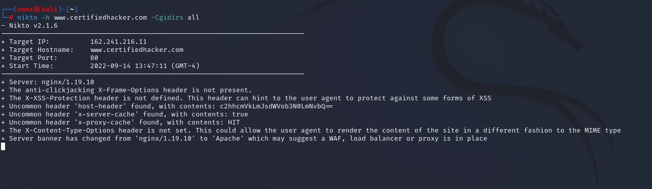

Step 5. Nikto will scan the webserver as it looks vulnerable CGI directories. It scans the webserver and list out the directories

**Out Put:**

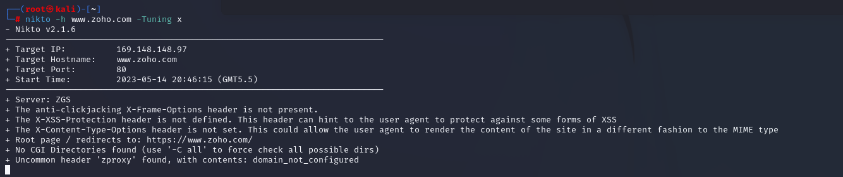

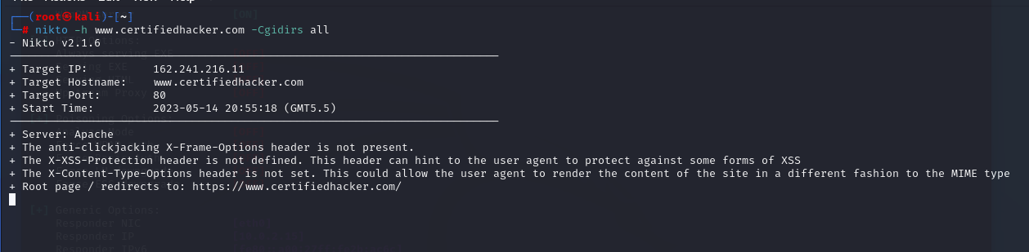

**Exercise No 8: WireShark sniffer**

**Aim: Use WireShark sniffer to capture network traffic and analyze.**

Procedure:

Step 1: Install and open WireShark .

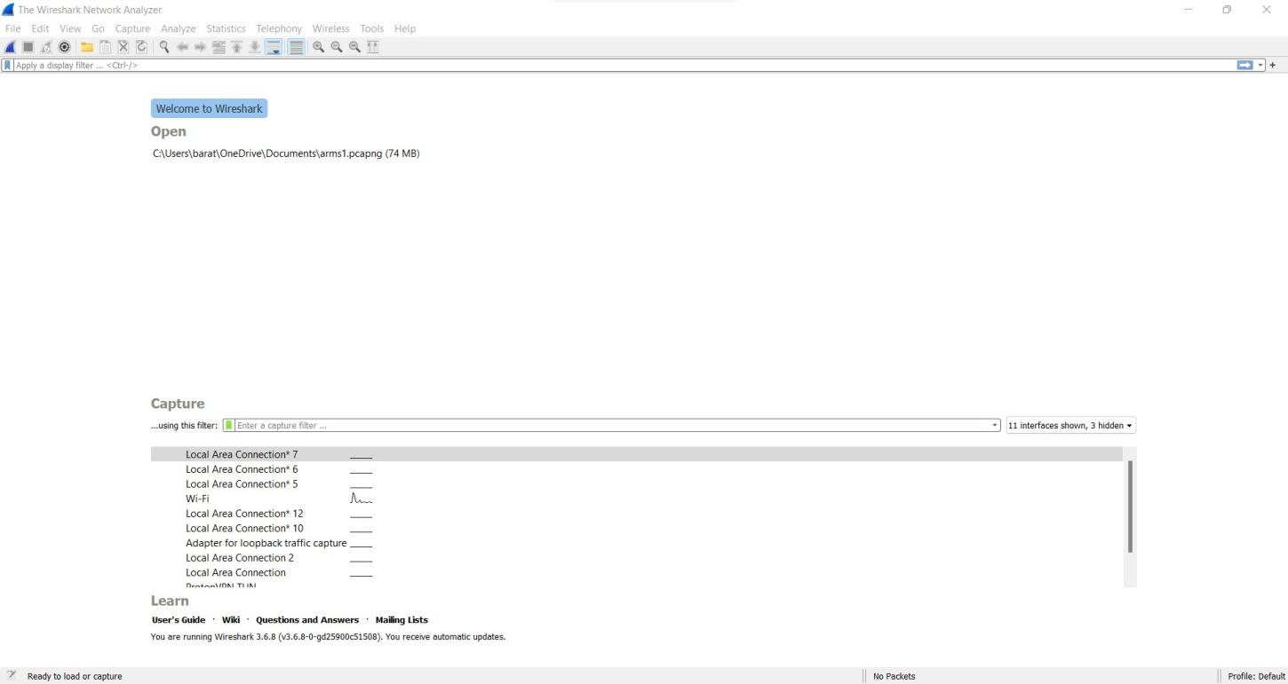

Step 2: Go to Capture tab and select Interface option. Here Wifi connection is chosen

Step 3: The source, Destination and protocols of the packets in the Wifi network are displayed

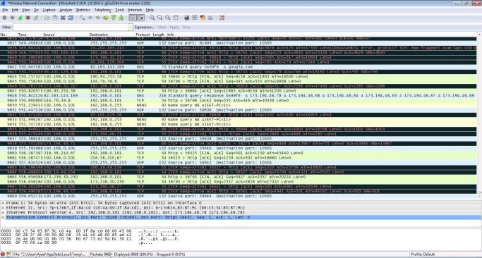

Step 4: Open a website in a new window and enter the user id and password. Register if needed.

Step 5:Enter the credentials and then sign in

Step 6: The wireshark tool will keep recording the packets.

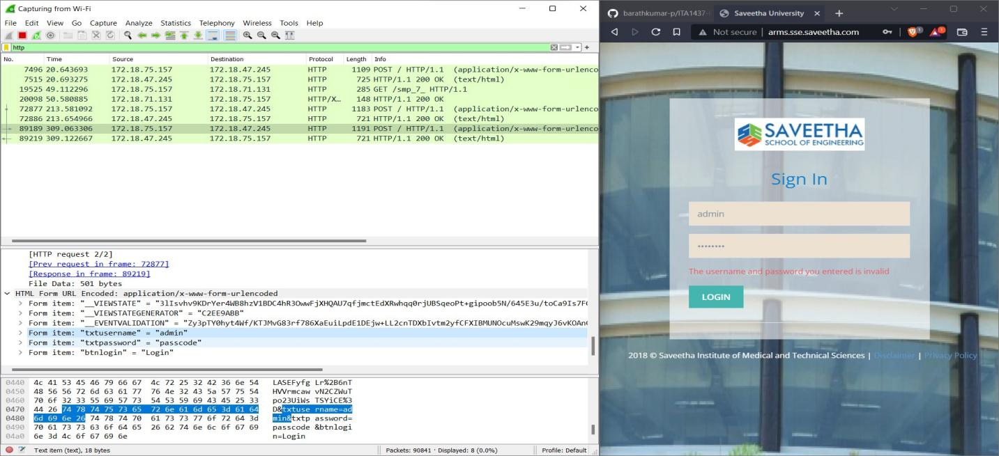Step 7: Select filter as http to make the search easier and click on apply. Step 9: Now stop the tool to stop recording

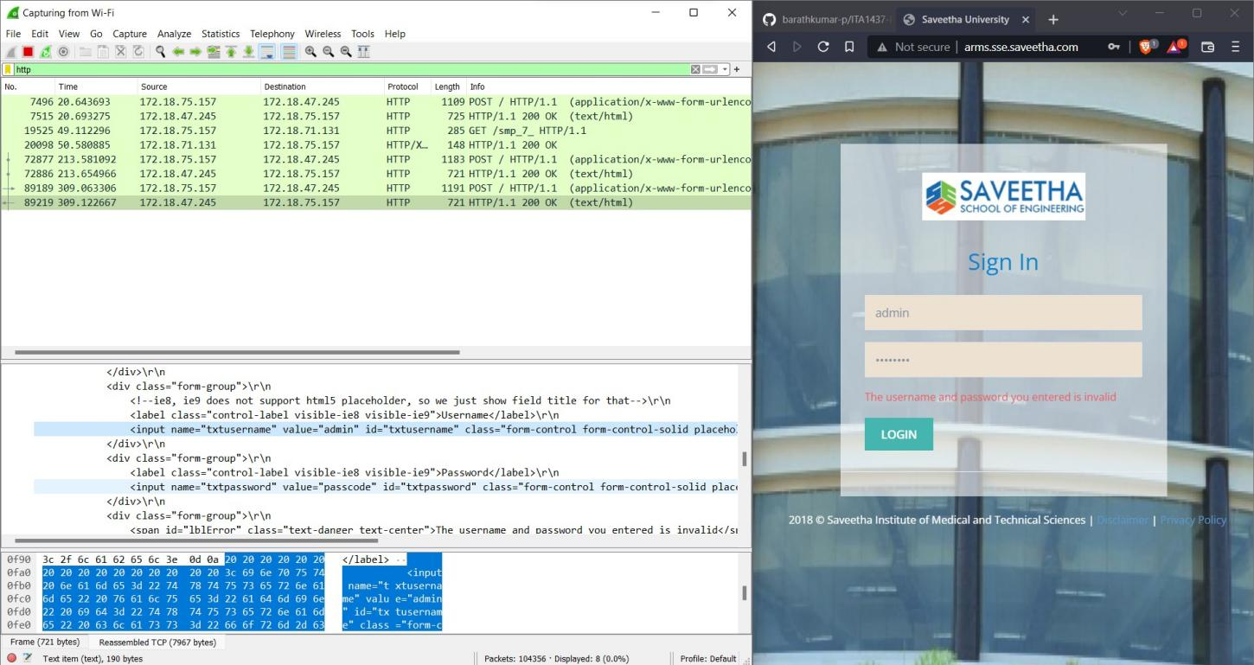

Step 10: Find the post methods for username and passwords

Step 11: U will see the email- id and password that you used to log in.

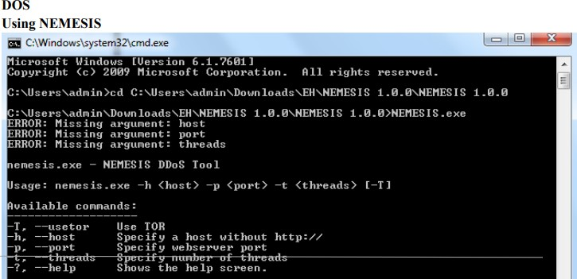

**Out Put:**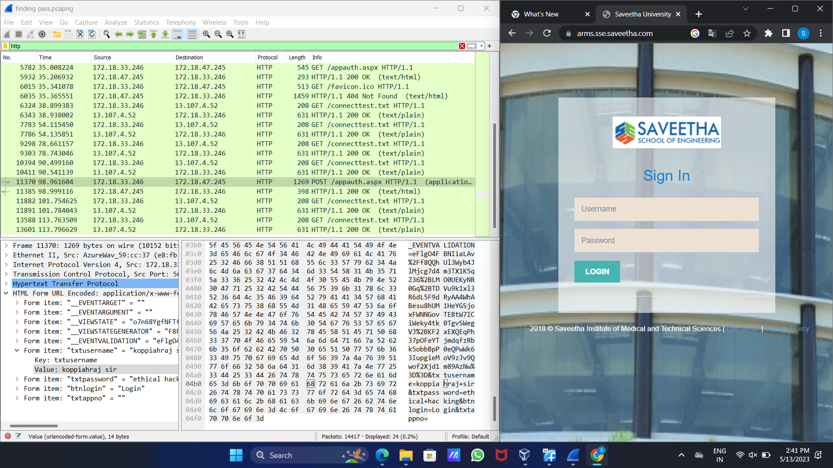

**Ex. No.9– ENUMERATION - Enumerating information from windows and Samba Host Using Enum4linux**

Requirements:

● Kali linux running as an attacker machine

● Windows 7 running as virtual machine

● Admin privileges

Procedure:

1.Start the kali linux machine and open a terminal window

2.Type “sudo apt-get update” command

3.Now type enum4linux-h and hit enter to get help options With the help options conduct the enumeration on target machine

4.In the terminal window type enum4linux -u -p -U and hit enter to run this tool using the user list options 5.Enum4linux starts enumerating the workgroups/domain names first and display the results

6.To enumerate all the information Use this command enum4linux -a

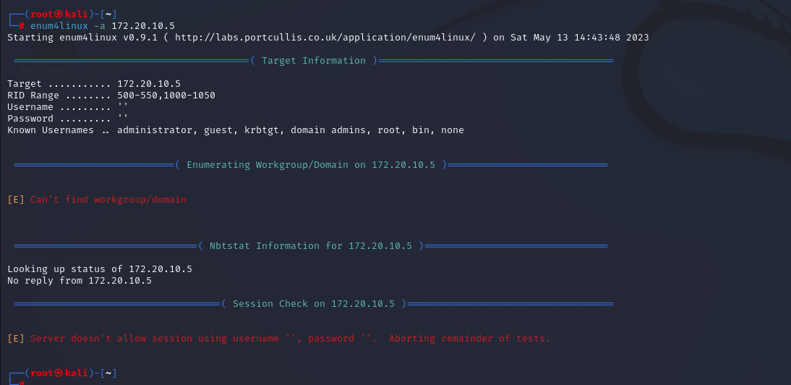

**EX.NO: 10 DATE: BATCH FILE EXECUTION**

**AIM:** To create a Windows batch file.

**PROCEDURE:**

**Step 1 :** Open a text file, such as a Notepad or WordPad document

**Step 2 :** Add your commands, starting **with @echo [off],** followed by, each in a new line, **title [title of your batch script], echo [first line],** and **pause.**

**Step 3 :** Save your file with the file extension **BAT,** for example, **test.bat.**

**Step 4 :** To run your batch file, **double-click the BAT file** you just created.

**Step 5 :** To edit your batch file**, right-click the BAT file** and select **Edit**.

And here's the corresponding command window for the example above:

**1.Create a New Text Document**

A batch file simplifies repeatable computer tasks using the Windows command prompt.

Below is an example of a batch file responsible for displaying some text in your command prompt.

Create a new BAT file by right-clicking an empty space within a directory and selecting **New, then Text Document**.

**1.CODE:**

Double-click this **New Text Document** to open your default text editor. Copy and paste the following code into your text entry.

**>> @echo off**

**>> echo hello**

**>> Pause**

**>> echo This is new**

**>> echo this is second one**

**>> pause**

1. **TO SAVE a BAT File**

The above script echoes back the text "Welcome to batch scripting!" Save your file by heading to **File > Save As,** and then name your file what you'd like. End your file name with the added **BAT** extension, for example **test.bat,** and click **OK**. This will finalize the batch process. Now, double-click on your newly created batch file to activate it.

**2.To RUN as BAT File**

Once you'd saved your file, all you need to do is **double-click your BAT file**. Instantly, your web pages will open. If you'd like, you can place this file on your desktop. This will allow you to access all of your favorite websites at once.

**OUT PUT:**

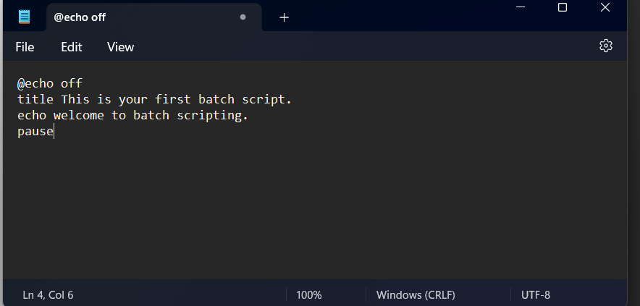

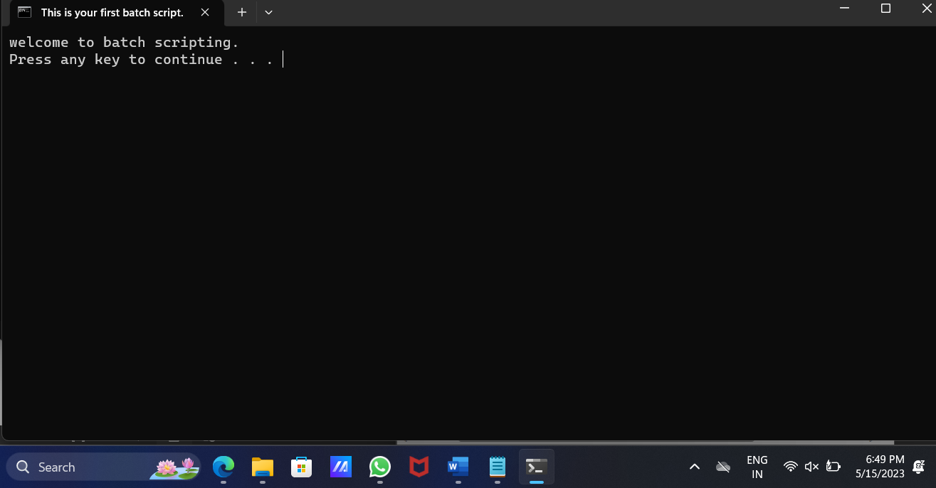

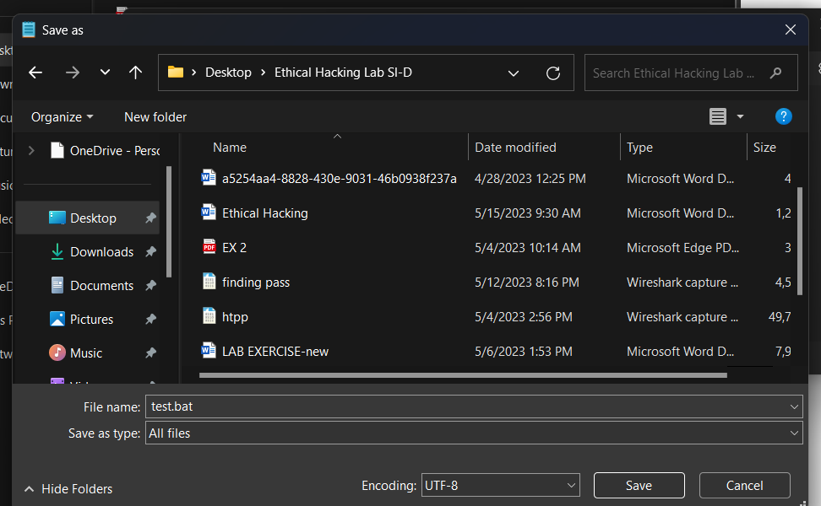

**RESULT:**

Thus the Creation and execution of BATCH FILE was successfully completed.